|  |  |  |  |
| --- | --- | --- | --- |
| **Version** | **Change Date** | **By** | **Description** |
| V0 | 4/06/2020 | Sean Boaden | First Version |
| V1 | 10/6/2020 | Gholamreza Aminy | Sprint 2 requirements applied |
| V2 | 17/06/2020 | Sean Boaden | Sprint 3 requirements |

MAster document

JMC Project

RAD Master Document

Contents

Analysis and Setup 3

SOURCE CONTROL 3

Task Matrix 3

Sprint One 4

SOURCE CONTROL 4

PROJECT MANAGEMENT PLAN 5

TEST PLAN 6

Introduction 8

Test Methodology 9

Resource & Environment Needs 11

Terms/Acronyms 11

ANALYSIS REPORT 12

CITE business rules for software development 12

CITE Managed Services Quality Assurance 13

Acme Entertainment Pty Ltd development requirements 13

MULTI-PLATFORM REPORT 15

Multi-Platform Tests 16

Sprint Two 21

1. Source Control snapshot 21

2. Software Review Plan 24

Software Review Plan 24

Purpose 24

Verification 24

Sprint Requirements 25

System Design 25

3. Performance Report 27

4. Updated Project Management Plan for Sprint Two 28

5. Updated Software Testing Plan which reflects the sprint two development 29

Test plan 29

Introduction 31

Scope 31

Quality Objective 31

Roles and Responsibilities 31

Test Methodology 32

Overview 32

Test Levels 32

Bug Triage 32

Suspension Criteria and Resumption Requirements 33

Test Completeness 33

Test Deliverables 33

Resource & Environment Needs 34

Testing Tools 34

Test Environment 34

Terms/Acronyms 34

6. Demonstrate the movie database application which uses the membership portal and administrative functions. 35

Task Matrix 35

TEST Document 35

References 38

# Analysis and Setup

Project Team members:

Sean Boaden

Troy Lucero

Gholamreza Aminy

SOURCE CONTROL

[GitHub](https://github.com/sean-b765/RAD-Project) repository

## Task Matrix

|  |  |  |  |  |  |  |
| --- | --- | --- | --- | --- | --- | --- |
| **Sprint One** | **GANTT Chart** | **Test Plan** | **Analysis Report** | **Multi-Platform Report** | **Source Control** | **Demonstration** |
| *Sean* |  |  |  | 29/05 | 2/06 |  |
| Aveneil | Completed 4/06 |  |  |  |  |  |
| Gholamreza |  | 29/05 |  |  |  |  |
| Troy |  |  | 1/06 |  |  |  |
|  |  |  |  |  |  |  |
| **Sprint Two** | **Update GANTT Chart** | **Update Test Plan** | **Software Review Plan** | **Performance Report** | **Source Control** | **Demonstration** |
| Sean |  | x | x |  |  |  |
| Gholamreza | x |  |  | x | x | x |
| Troy |  |  |  |  |  |  |
| **Sprint Three** | **Update GANTT Chart** | **Update Test Plan** | **Optimisation Report** |  | **Source Control** | **Demonstration** |
| Sean | x | x |  |  | x |  |
| Gholamreza |  |  | x |  |  |  |
| **Assessment Point Four** |  |  |  |  |  | **Demonstration** |
| Sean |  |  |  |  |  |  |
| Gholamreza |  |  |  |  |  |  |
|  |  |  |  |  |  |  |
|  |  |  |  |  |  |  |
|  |  |  |  |  |  |  |

# Sprint One

Scrum Master: Sean B

## SOURCE CONTROL

Project from Web Programming will be uploaded to GitHub. At the end of Sprint one, changes will have been pushed to master branch.

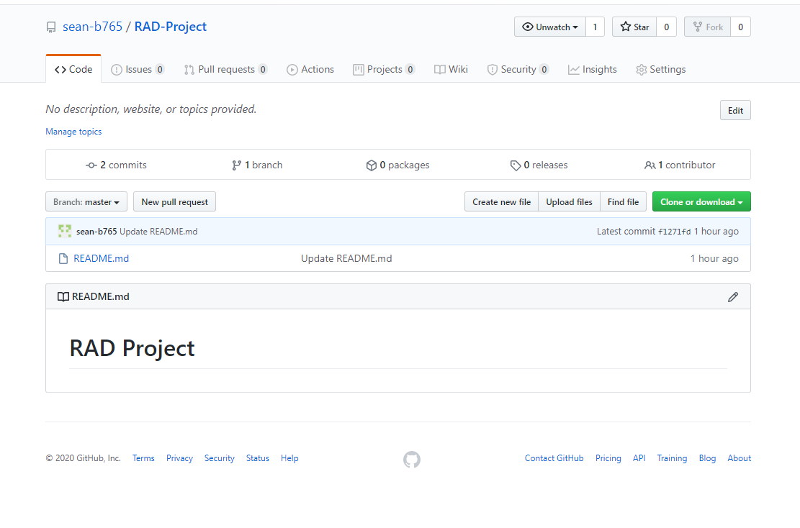

Pull Requests

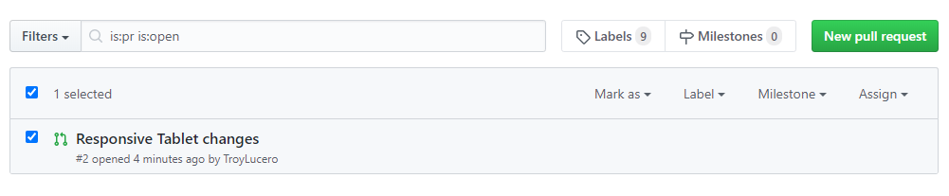

## PROJECT MANAGEMENT PLAN

By: Aveneil

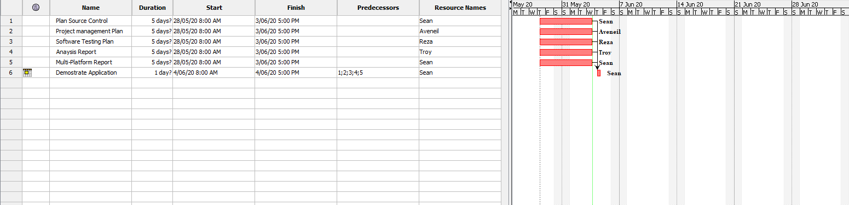

## TEST PLAN

By: Gholamreza

**Project: Movie Database**

**Client: Acme Entertainment Pty Ltd**

|  |  |  |  |
| --- | --- | --- | --- |
| **Version** | **Change Date** | **By** | **Description** |
| V0 | 28/5/2020 | Group G | First Version |
|  |  |  |  |
|  |  |  |  |

Test plan 1

1. Introduction 3

Scope 3

In Scope 3

Out of Scope 3

Quality Objective 3

Roles and Responsibilities 3

2. Test Methodology 4

Overview 4

Test Levels 4

Bug Triage 4

Suspension Criteria and Resumption Requirements 5

Test Completeness 5

3. Test Deliverables 5

4. Resource & Environment Needs 6

Testing Tools 6

Test Environment 6

5. Terms/Acronyms 6

### Introduction

#### Scope

##### In Scope

The whole package including GUI, functional and non-functional requirements of the software are in the scope of this document and will be tested in different stages and sprints.

##### Out of Scope

None

#### Quality Objective

The ultimate objective of this plan is to ensure the application under test meets the functional and non-functional requirements as agreed on the contract. The AUT will also be a quality and user friendly product with no bugs.

#### Roles and Responsibilities

To ensure a clear understanding of the roles and responsibilities to achieve the above-mentioned quality objective the following roles and responsibilities are defined for this plan:

* Test Manager: has the overall responsibility of executing this plan. Test manager will schedule and implement the tests and set action plans to rectify the triaged bugs in cooperation with other team members
* QA Analyst: QA Analyst has the responsibility to monitor the proper implementation of this plan, perform regular audits and report to the Test Manager for corrections and Project Manager for further decisions.
* Configuration Manager
* Developers: are responsible to understand and analyze the assigned tasks and do the task on the assigned time ready for test. They will fix defined bugs during the tests reported by the Test Manager.
* Installation Team: They are responsible to ensure the software can be installed with minimum efforts and report any bugs to the Test Manager

### Test Methodology

#### Overview

Choosing the RAD software development requires a suitable test method like Agile in which all the functional and non-functional tests can be completed in each sprint. So the Agile method will be used for this testing plan as in Agile:

* software is developed in incremental, rapid cycles
* Interactions amongst customers, developers and client are emphasized
* focuses on responding to change rather than extensive planning
* every release of the project is tested thoroughly
* any bugs in the system are fixed before the next release

#### Test Levels

Test Levels define the Types of Testing to be executed on the Application Under Test (AUT).

The AUT will be tested in the below levels

* System Testing.
* Acceptance Testing.

The following tests will be performed to ensure clients requirements:

* Functional and Regression Testing;
* GUI and Usability Testing;
* Accessibility Testing;
* Performance Testing;
* System / Integration Testing;
* User Acceptance Testing (UAT).

#### Bug Triage

To ensure fixing the bugs in a timely manner it is absolutely important to prioritize them so that the urgent ones, which are mainly functional reuquirements, get priority in scheduling the tasks to fix the bugs.

The triage would be based on the following requirements:

* GUI and Usability
* Functional
* Accessibility
* Performance

#### Suspension Criteria and Resumption Requirements

Due to size of the project, there is no suspension and resumption criteria.

#### Test Completeness

Test process will be consicered complete if the following is met:

* 100% test coverage
* All Manual & Automated Test cases executed
* All open bugs are fixed or will be fixed in next release

#### Test Deliverables

During different phases of the testing lifecycle the following deliverables should be delivered to ensure the testing process is completed and validated:

* Test Plan
* Test Cases
* Bug Reports
* Test Strategy
* Test Metrics
* Customer Sign Off

### Resource & Environment Needs

#### Testing Tools

To run the testing plan the following tools are required and will be used:

* Test Management Tool
* Configuration management tool
* Static Analysis Tools

#### Test Environment

To test the application a test environment including hardware and software environement is equired in addition to the client specific ones.

Required hardware:

* Computer desktop
* Modem
* Flash memory

Required software:

1. Windows 10
2. Office 360
3. MS Exchange

### Terms/Acronyms

Make a mention of any terms or acronyms used in the project

| TERM/ACRONYM | DEFINITION |
| --- | --- |
| API | Application Program Interface |
| AUT | Application Under Test |

## ANALYSIS REPORT

By Troy

### CITE business rules for software development

CITE Managed Services Business Analysts define easier ways to attain what you need, while Project Managers identify the most suitable development methodology and cooperation model, as well as assemble the most effective project team, and the tech experts work on technical feasibility and select the most efficient technologies.

We are strongly committed to securing business processes from end to end and respecting our customers’ intellectual property rights and data. With this in mind, we have established a set of corporate policies and procedures that every employee must comply with such as account, data, and physical security, along with more specialized policies covering internal applications and systems that employees are required to follow.

#### Clients

Our clients’ interests always come first. If we deliver exceptional product and service to our clients, our own success will follow.

#### Accountability

We are performance oriented and unafraid to make decisions and be held accountable for those decisions.

#### People and reputation

These are our greatest assets. Without compromise, we will operate in an ethical manner and in compliance with regulations, wherever we work, and whoever we work with.

#### Professionalism and quality

We take great pride in our work and are driven to achieve excellence in every project we undertake. We aim to deliver the best products and service in the market.

#### Innovation, creativity

We never discount the past, but we will constantly strive to find a better solution to a client’s problems. Our clients’ best interests are our best interests.

#### Teamwork

Individual creativity is always encouraged, but, more often than not, team effort produces the best results. There is no room for those who put their personal interests ahead of the interests of the firm and its clients.

#### Size

We are a small firm. We want to be big enough to undertake the largest project that any of our clients could conceive, yet small enough to maintain the loyalty and camaraderie that contributes to our success.

#### Anticipation

We constantly strive to anticipate changes in markets and technologies and we will deliver the latest services, tools and technology stacks to our clients.

#### Growth

We operate in a highly competitive environment and we will grow our business aggressively. However, we will always be fair competitors and will never denigrate other firms.

Reference: <http://www.citems.com.au/?page_id=74>

### CITE Managed Services Quality Assurance

CITE Managed Services performs quality assurance throughout the entire software development lifecycle with QA team members being involved at all stages.

A Lead QA specialist is assigned at the commencement of each project and is involved into initial business analysis and requirements specification. Such a simultaneous interaction of our development and QA teams provides for a better understanding of the project scope and the client’s business objectives.

Comprehensive Approach to Quality:

Quality Planning

CITE Managed Services puts together quality plans that govern the applicable set of standards, regulations, procedures, guidelines and tools during the development lifecycle in each project.

Quality Assurance

We have established processes that evaluate project performance and aim to assure that quality standards are being followed and that the deliverables comply with customer requirements.

Quality Control

We measure performance trends to identify defective pieces of code, verify that deliverables are of high quality and that they are complete and correct.

### Acme Entertainment Pty Ltd development requirements

Acme Entertainment have commissioned a prototype movie database, however they want to review and update this application so it can be used across all the major digital platforms. They require a Multi-Platform Report on the merits of the two design options currently used; adaptive and responsive.

Each requirement must be verified and validated to ensure that these are the correct requirements. If the requirements have been accepted and a baseline is established by the stakeholders. Any changes to the requirements are controlled using a Configuration Management process.

The development or migration of the movie database can be hosted on the cloud or suitable local server. Conduct and record suitable testing of the completed development, include this information in the Testing Plan.

Functional Requirements

• Website needs to be adaptive or responsive.

• Accessible from multiple devices

• Can search movies by individual categories or altogether.

• Readability.

Non-functional Requirements

• No bugs or glitches

• Easily accessible

## MULTI-PLATFORM REPORT

***By: Sean***

When choosing between responsive and adaptive design, you should take into account the target audience of your website/business, and plan according to the most used devices within this demographic.

The design to be implemented in **our project** is a **responsive design**. It may be quicker to implement a responsive design over the adaptive web design as adaptive requires multiple stylesheets. Adaptive will often grant *quicker* site load times (especially on mobile), but there are mixed results as to which design can produce the best load time. If no optimization is made to a responsive website, the adaptive solution often loads faster, despite requiring multiple stylesheets.

Basically, responsive web design can produce quicker load times on desktop, while mobile users can get much quicker load times using the adaptive design. For this reason, target audience is vital.

Improper use of media queries can result in mobile devices loading full desktop styles, rather than only the needed mobile styles. A media query is an expression which will check the screen size, and resolve to true or false depending on if the condition is met. E.g.

@media only screen and (min-device-width : 320px) and (max-device-width : 767px) {

    /* Styles */

}

Will check if the device browser width is between 320 and 767 pixels. If the condition is not met, the inner styles will be ignored.

Studies done by Google show that the average user will expect a website to load in under 3 seconds before they consider leaving.

The responsive design will respond quickly to the size of the screen due to CSS media queries. This means only one CSS stylesheet is required, although it will be a larger file. The adaptive design will adapt to the screen size depending on a set of width constraints. There will be no fluid UI changes, and instead the layout will snap to the given screen size constrains when resizing the browser. This can result in some irregular-sized devices having a crowded or lackluster design in some cases.

**Common size constraints:**

The most important factor in screen size is width.

The typical **Mobile** screen width will be **below 768** pixels, when taking landscape mode into account.

A **Tablet** screen will have a width **between 1024 and 768** pixels.

The **Desktop** screens will have a width **above 1024** pixels.

**Responsive VS Adaptive design**

|  |  |
| --- | --- |
| **Responsive** | **Adaptive** |
| Requires one larger spreadsheet. | Labour-intensive, requires multiple stylesheets. |
| Browser loads one large stylesheet. | Browser loads multiple stylesheets. |
| Easier to implement. | Time-consuming. |
| More flexible as browser size changes will produce fluid UI changes. | Changing browser width will not reposition elements immediately. The stylesheet is only adapted at specific width constraints.  This can cause problems on devices which use an irregular screen size. |
| SEO (Search Engine Optimisation) favours Responsive Design, despite load times. | Challenging to SEO – A responsive site will most likely be shown first in Google search results. |

### Multi-Platform Tests

*by Sean*

**Tablet** layout (portrait):

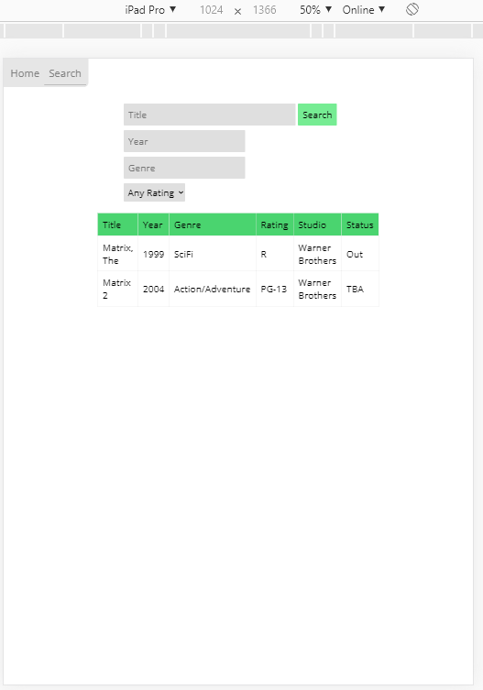

**Tablet** (landscape):

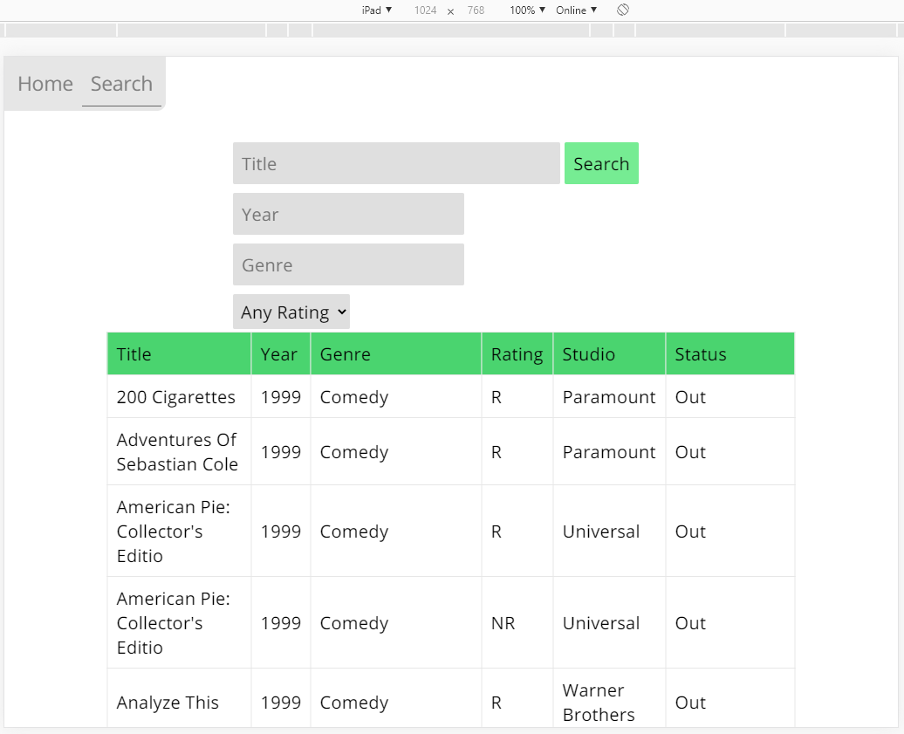

**Mobile** (portrait):

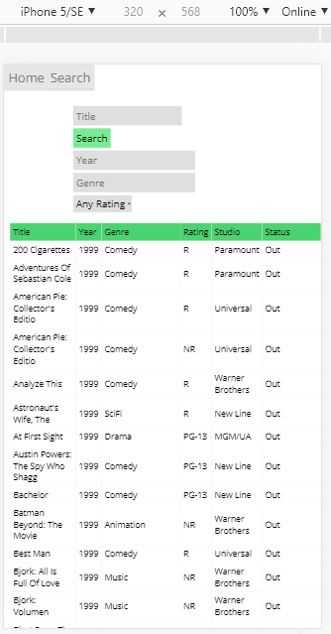

**Mobile** (landscape):

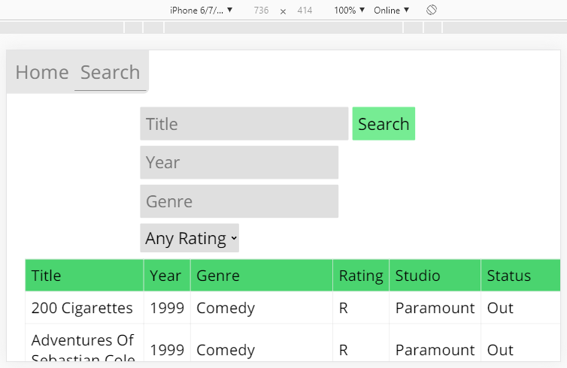

**Desktop**:

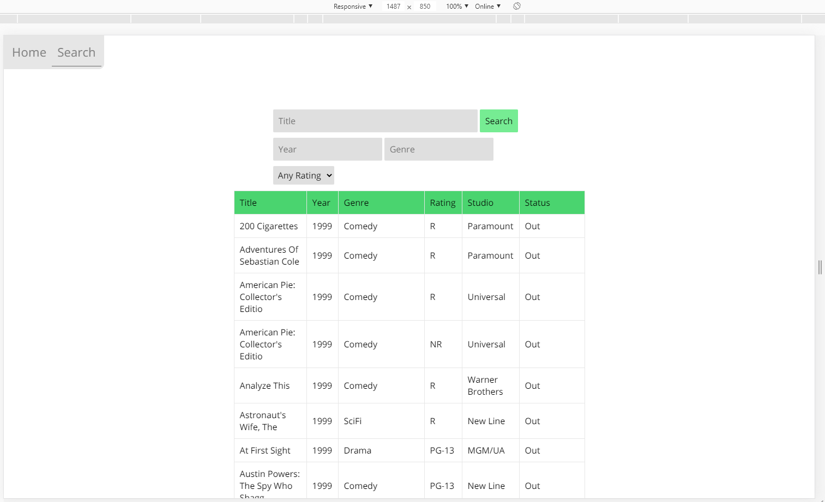

**Home Page** in different sizes

|  |  |
| --- | --- |
|  |  |
|  | |

|  |  |
| --- | --- |
| *Testing the bounds of the Search function…*  **No search filters/Title:** | Only 1 filter applied: **Year = 1** |
| **Genre = a** | **Title = ‘ OR 1 == 1**    The user could possibly find a vulnerability here, so I can insert an IF statement into the code to check that *$result is TRUE* (an error has occurred if mysqli_query() returns false) |
|  | |

SPRINT TWO

# Sprint Two

Scrum Master: Gholamreza Aminy

## SOURCE CONTROL SNAPSHOT

During the project modification as per JMC management requirements the following changes were applied into the source control:

* A new “members” table has been added to the data base to store the members information
* Login fields have been added to the home page to allow users to login to the system
* Signup page has been added to enable new members to register

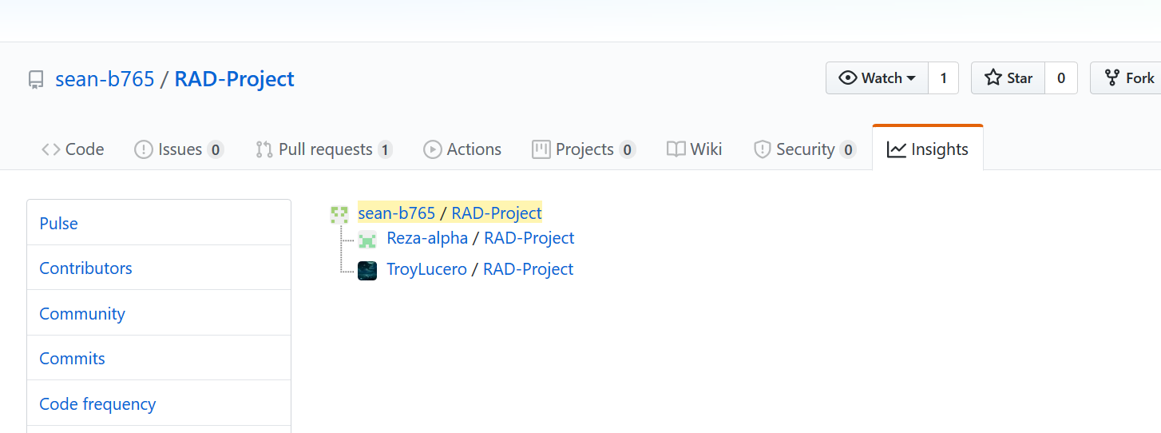

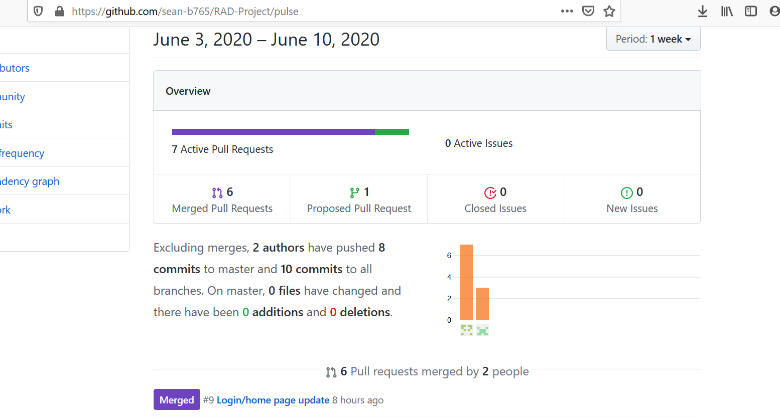

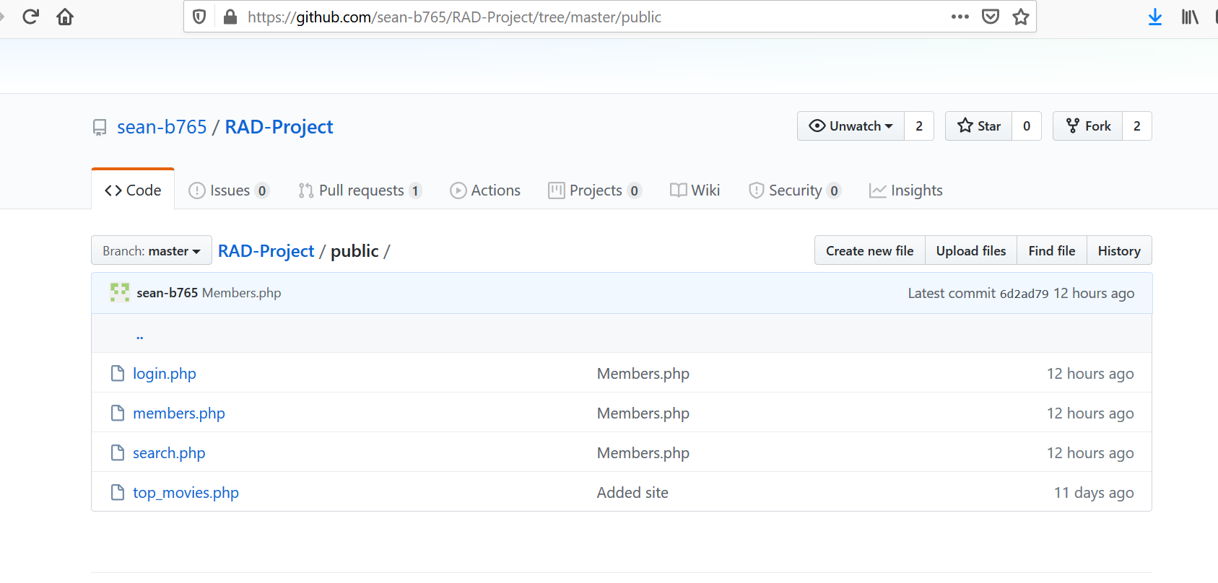

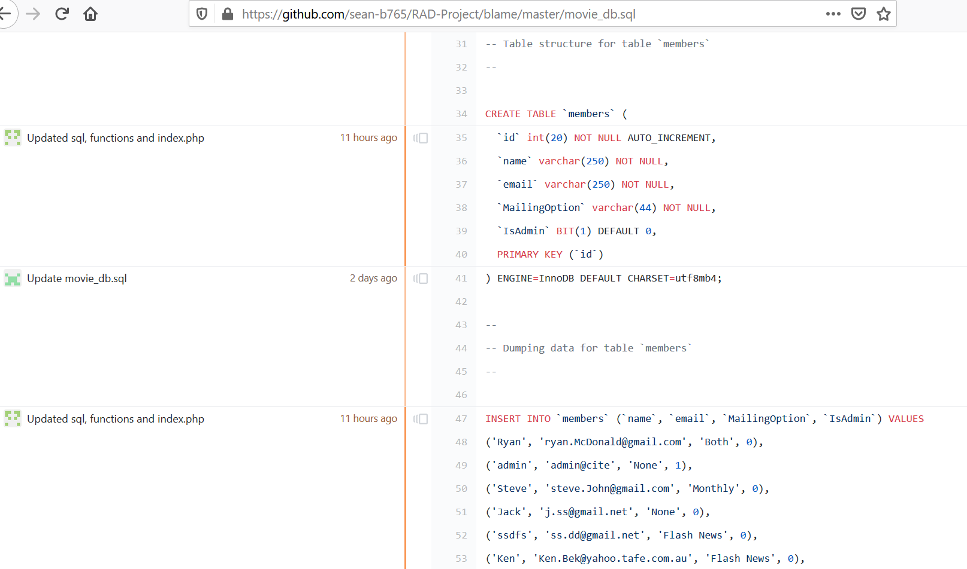

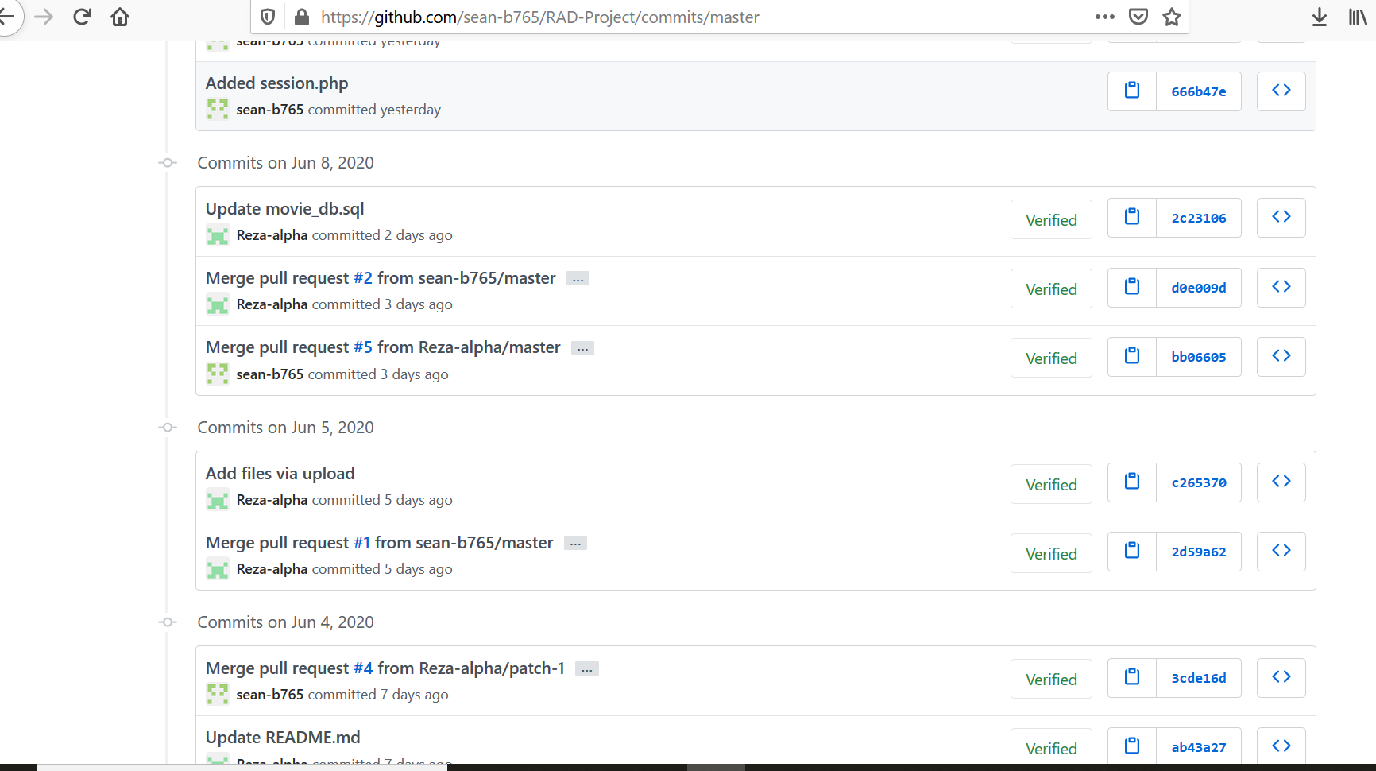

## UPDATED PROJECT MANAGEMENT PLAN

As one of the team members left the company, current team is smaller and tasks are a bit condensed. The team decided to

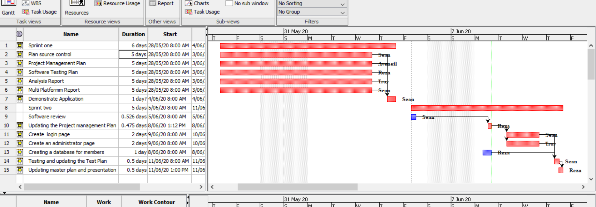

Troy one of team members was not attending the project to meet milestones. The work load was shared between other team members. The issue was raised to client who advised the team to have a meeting to rectify the issue. To fulfil client requirements, a meeting will be held to clarify the project team work load and applying a catch-up plan.

So the final achievement was as below

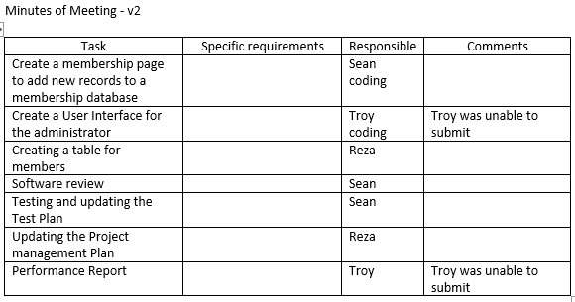

## UPDATED SOFTWARE REVIEW PLAN

By Sean

### Purpose

The purpose of this Software Review Plan is to verify the requirements, test plan and outline testing documentation for the project at hand. This report will allow team members to gain a better understanding of this sprint.

### Verification

During development, team members are expected to be familiar with requirements and relevant coding standards, such as naming conventions. Verification can be performed regularly by the Scrum Master, and can be done by meeting with developers for code review.

Verification is required to ensure development is being carried out properly and in an efficient manner, avoiding unnecessary features (gold-plating), and to make sure standards and regulations are being met.

* Functional and Non-Functional requirements from previous Sprint have been fulfilled…

Functional

* Website is a responsive design
* Accessible from desktop, tablet, and mobile devices
* Searching a movie by individual filters, search terms or a mix
* Code has been commented and is readable

Non-Functional

* No bugs, glitches
* Interface is user friendly and accessible
* User Interface test has been documented
* Functionality test has been performed and documented (for search page)

Standards and Business Rules

* CITE Business Rules have been incorporated in this project.
* ISO 12207:2017 Software Standards and coding conventions have been implemented.
* Modularity: classes are separated between files, and project file structure is consistent and logical.
* Naming conventions follow camel case, as should be the standard in web development.
* Sufficient commenting
* Sufficient reports and documentation
* Code formatting and indentation is consistent

### Sprint Requirements

Functional:

* Membership sign up form via Full name and Email address.
  + Option to join the mailing list at sign up
    - Option of monthly newsletter, or
    - Breaking newsflash emails (or both)
* Membership portal page
  + Enter email address to be removed from mailing list which gets sent to administrator
* Admin Portal
  + View all members
  + Enter an email address to be removed from the mailing list
* Reports
  + Testing Report (Software Testing Plan update)
  + Testing Plan (test documentation of User Interface, functionality…)
  + Performance Report
  + Project Management Plan

Non-Functional:

* The newly added pages should follow a responsive design
* Validate and sanitize user inputs

### System Design

#### Database

The original database already consists of movies, top_searches tables. The following Member table will need to be created, and default admin records insertted.

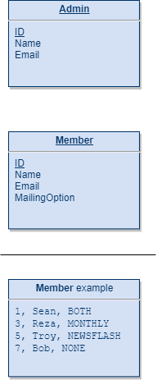

#### User Interface

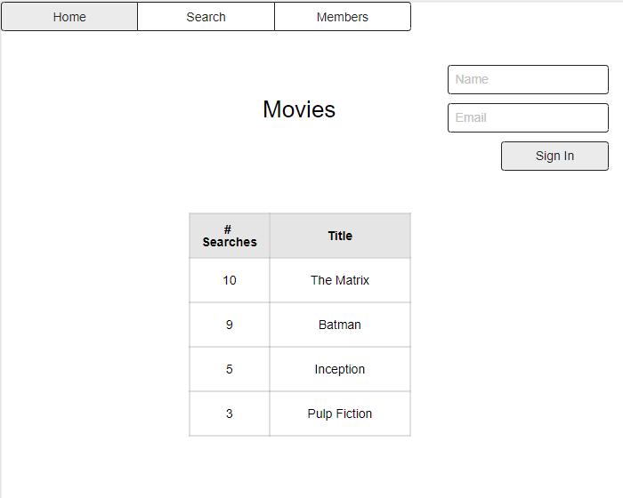

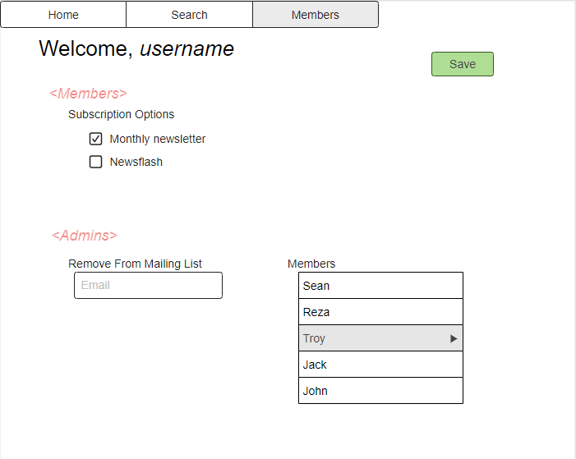

## PERFORMANCE REPORT

TROY’s FILE HERE

## TEST PLAN

**Project: Movie Database**

**Client: Acme Entertainment Pty Ltd**

|  |  |  |  |
| --- | --- | --- | --- |
| **Version** | **Change Date** | **By** | **Description** |
| V0 | 28/5/2020 | *Gholamreza Aminy* | First Version |
| V1 | 7/06/2020 | *Sean Boaden* | updated to meet requirements of Sprint Two |
|  |  |  |  |

Test plan 1

1. Introduction 3

Scope 3

In Scope 3

Out of Scope 3

Quality Objective 3

Roles and Responsibilities 3

2. Test Methodology 4

Overview 4

Test Levels 4

Bug Triage 4

Suspension Criteria and Resumption Requirements 5

Test Completeness 5

3. Test Deliverables 5

4. Resource & Environment Needs 6

Testing Tools 6

Test Environment 6

5. Terms/Acronyms 6

### Introduction

#### Scope

#### In Scope

The whole package including GUI, functional and non-functional requirements of the software are in the scope of this document and will be tested in different stages and sprints.

#### Out of Scope

None

#### Quality Objective

The ultimate objective of this plan is to ensure the application under test meets the functional and non-functional requirements as agreed on the contract. The Application Under Test will also be a quality and user friendly product with no defects.

#### Roles and Responsibilities

To ensure a clear understanding of the roles and responsibilities to achieve the above-mentioned quality objective the following roles and responsibilities are defined for this plan:

* Test Manager: has the overall responsibility of executing this plan. Test manager will schedule and implement the tests and set action plans to rectify the triaged bugs in cooperation with other team members
* QA Analyst: QA Analyst has the responsibility to monitor the proper implementation of this plan, perform regular audits and report to the Test Manager for corrections and Project Manager for further decisions.
* Configuration Manager
* Developers: are responsible to understand and analyze the assigned tasks and do the task on the assigned time ready for test. They will fix defined bugs during the tests reported by the Test Manager.
* Installation Team: They are responsible to ensure the software can be installed with minimum efforts and report any bugs to the Test Manager

### Test Methodology

#### Overview

Choosing the RAD software development requires a suitable test method like Agile in which all the functional and non-functional tests can be completed in each sprint. So the Agile method will be used for this testing plan as in Agile:

* software is developed in incremental, rapid cycles
* Interactions amongst customers, developers and client are emphasized
* focuses on responding to change rather than extensive planning
* every release of the project is tested thoroughly
* any bugs in the system are fixed before the next release

#### Test Levels

Test Levels define the Types of Testing to be executed on the Application Under Test (AUT).

The AUT will be tested in the below levels

* White Box Tests
  + Branch Coverage tests – can be performed on certain conditional operations. It is important that conditional bounds are tested on certain points, to ensure the application works well.
* Black Box Tests
  + **Functional tests** – where the new membership portal inputs will be tested. Sign up / sign in functions, administrative functions should be tested and documented.
  + **User interface** tests – will be used to test that the new members page follows the responsive design.

The following tests will be performed to ensure clients requirements:

* Functional and Regression Testing;
* GUI and Usability Testing;
* Accessibility Testing;
* Performance Testing;
* System / Integration Testing;
* User Acceptance Testing (UAT).

#### Bug Triage

To ensure fixing the bugs in a timely manner it is absolutely important to prioritize them so that the urgent ones, which are mainly functional reuquirements, get priority in scheduling the tasks to fix the bugs.

The triage would be based on the following requirements:

* GUI and Usability
* Functional
* Accessibility
* Performance

#### Suspension Criteria and Resumption Requirements

Due to size of the project, there is no suspension and resumption criteria.

#### Test Completeness

Test process will be considered complete if the following is met:

* 100% test coverage.
* All Manual & Automated Test cases executed
* All open bugs are fixed or will be fixed in next release

#### Test Deliverables

During different phases of the testing lifecycle the following deliverables should be delivered to ensure the testing process is completed and validated:

* Test Documentation Report
  + Test Plan
  + Test Cases
  + Bug Reports
  + Test Strategy
  + Test Metrics
* Customer Sign Off

### Resource & Environment Needs

#### Testing Tools

To run the testing plan the following tools are required and will be used:

* Test Management Tool
* Configuration management tool
* Static Analysis Tools

#### Test Environment

To test the application a test environment including hardware and software environement is equired in addition to the client specific ones.

Required hardware:

* Computer desktop
* Modem
* Flash memory

Required software:

1. Windows 10
2. Office 360
3. MS Exchange
4. XAMPP or similar web server software packages including MySQL and Apache

#### Terms/Acronyms

Make a mention of any terms or acronyms used in the project

| TERM/ACRONYM | DEFINITION |
| --- | --- |
| API | Application Program Interface |
| AUT | Application Under Test |

## TEST DOCUMENT

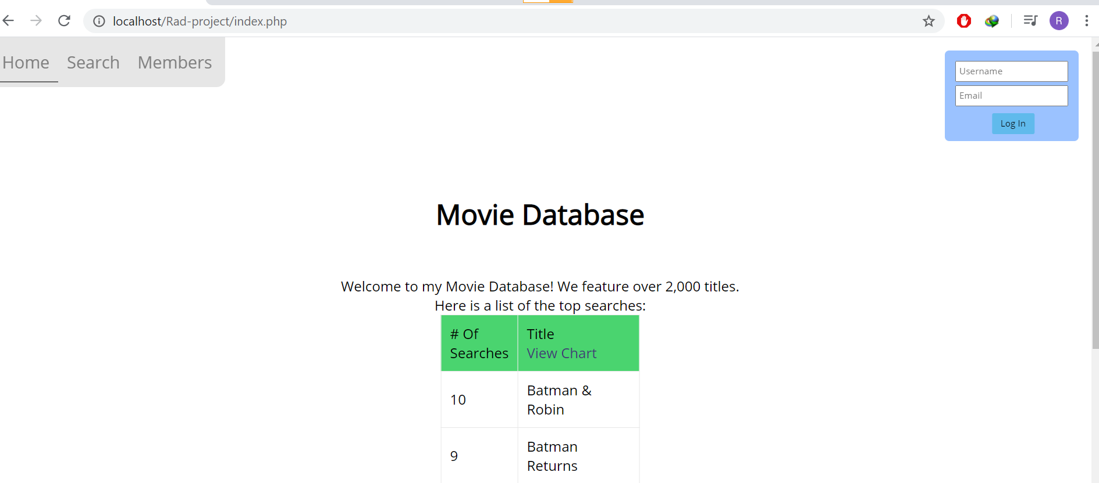

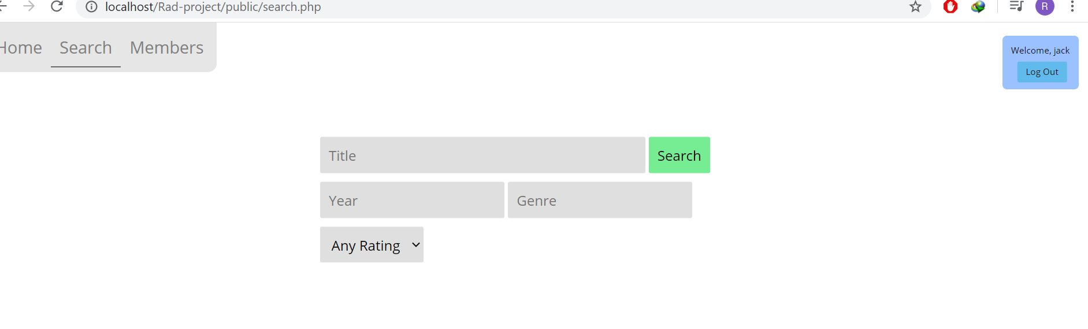

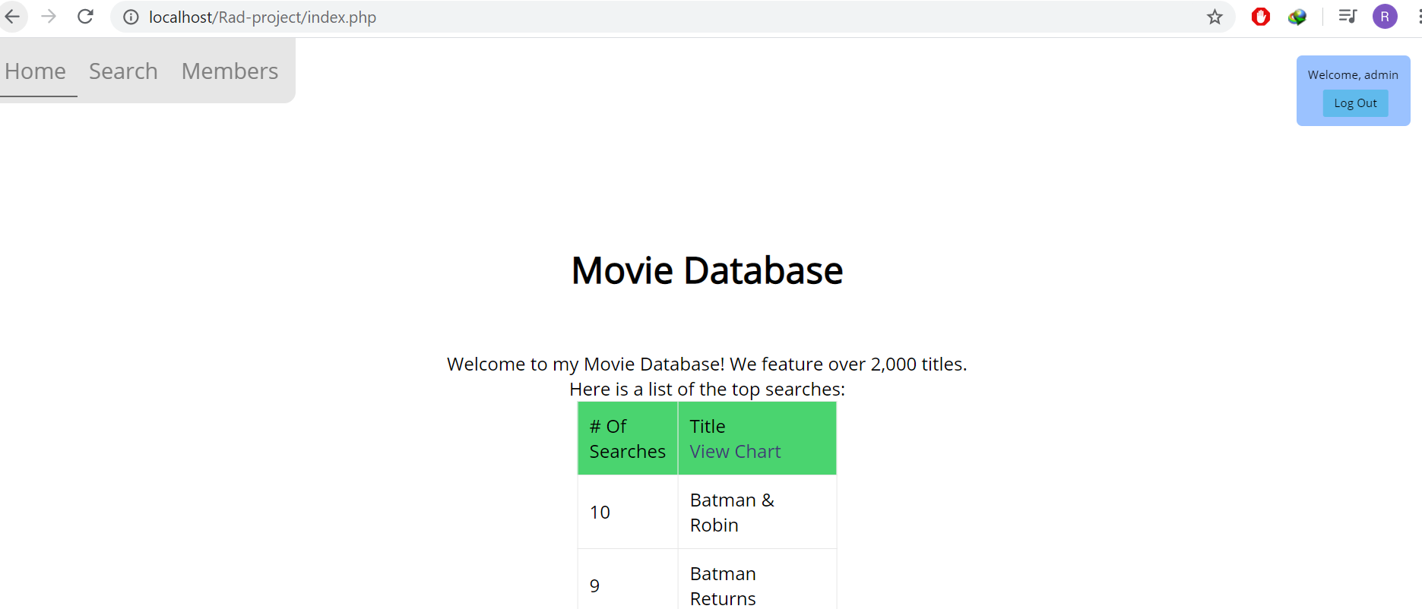

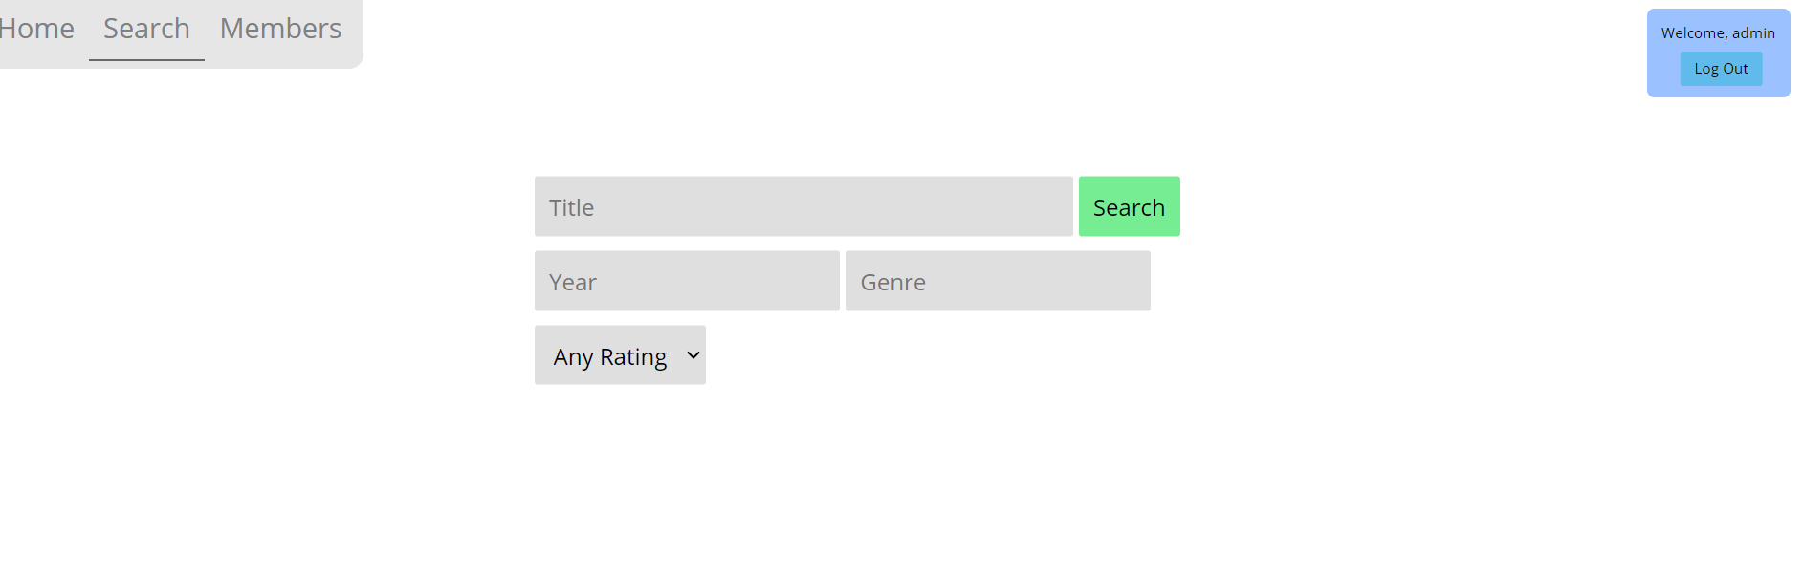

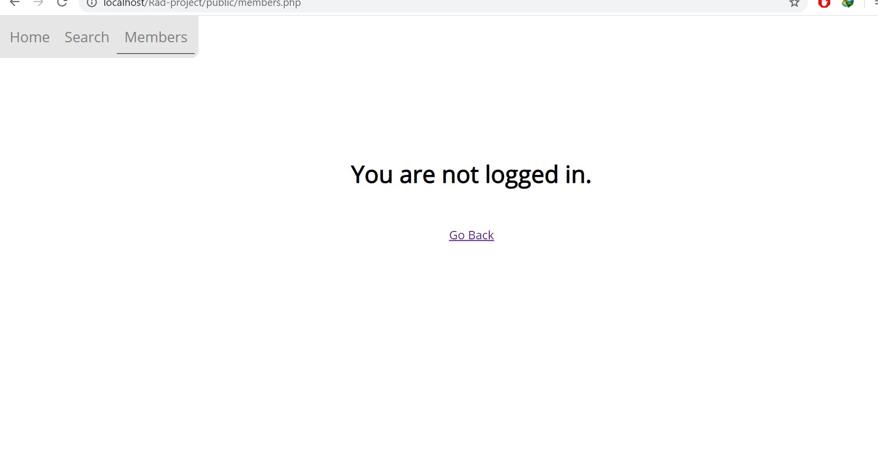

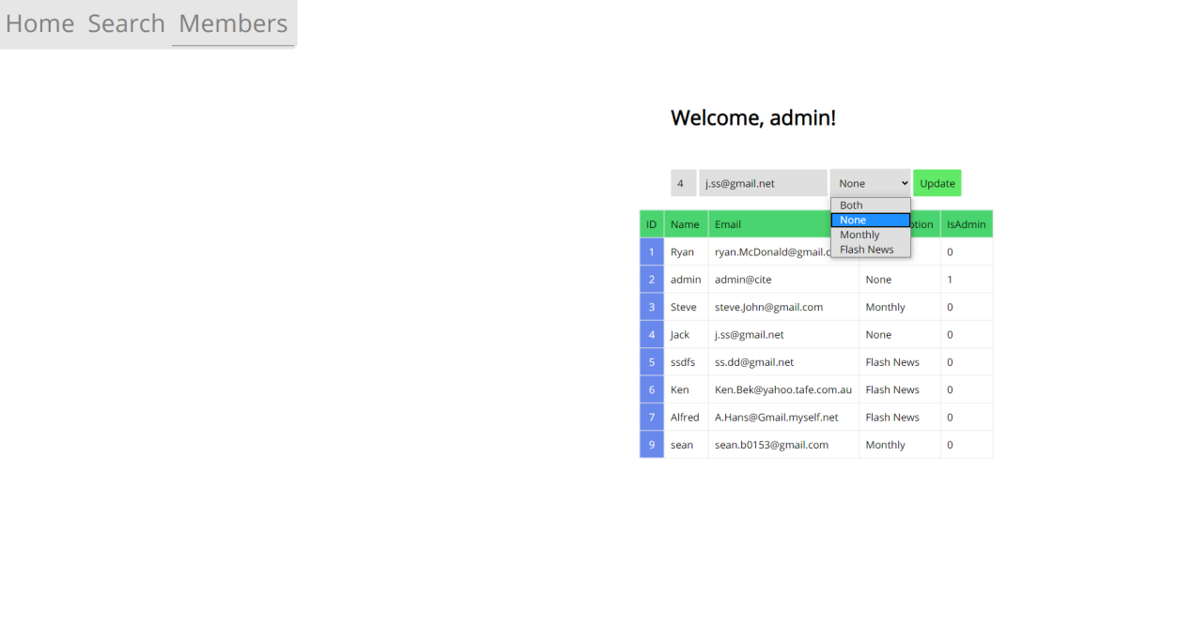

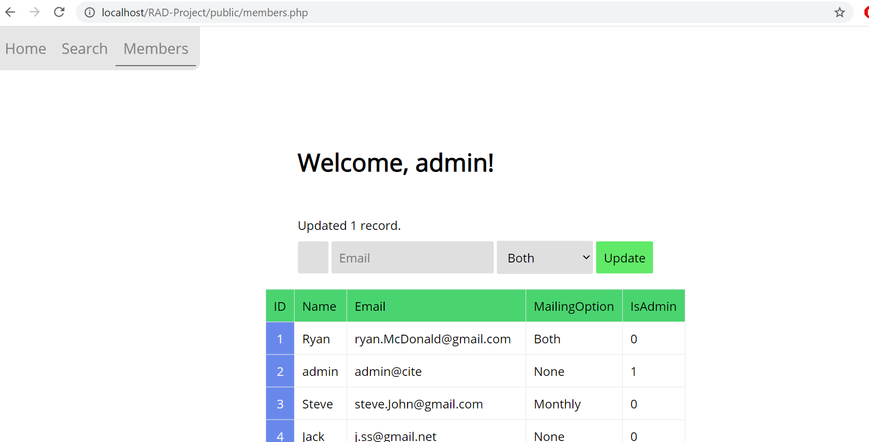

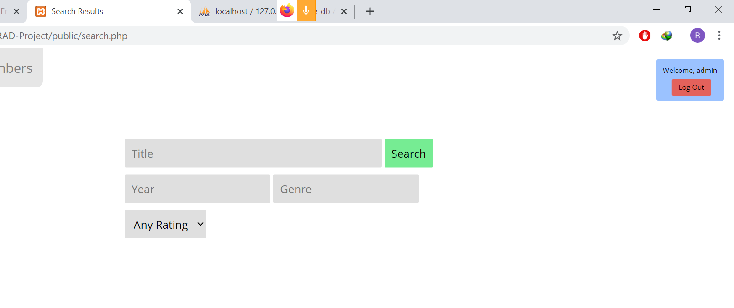

# Sprint Three

Scrum Master: Sean Boaden

## Marking Criteria

|  |
| --- |
| The team has updated the source control system with the sprint three code and associated documents. |
| The team has a Project Management Plan completed up to the sprint three assessment milestone. |
| Update Software Testing Plan document that reflects the spring three development phase |
| The Movie Database Application functions correctly using administrator password. |
| The Movie Database Application display top 10 information. |
| The presenter can explain how the administrator sign-in works, with different users and groups. |
| The analytics web page display streamed data |
| Documentation for Optimisation Report |

## SOURCE CONTROL SNAPSHOT

The following changes were applied into the source control:

* New DB tables include Groups, Group_Members, and Member_Ratings and Streaming
* New columns include AvgRating, TotalIntegerRating, and NumberOfRatings in table Movies. Members table now has Password column.
* If an Admin or ACME user has no password, a ‘Change Password’ message appears to get them to set their password. The Password must be 8 characters, alphanumeric and the Password will only be set if it reaches this criteria.

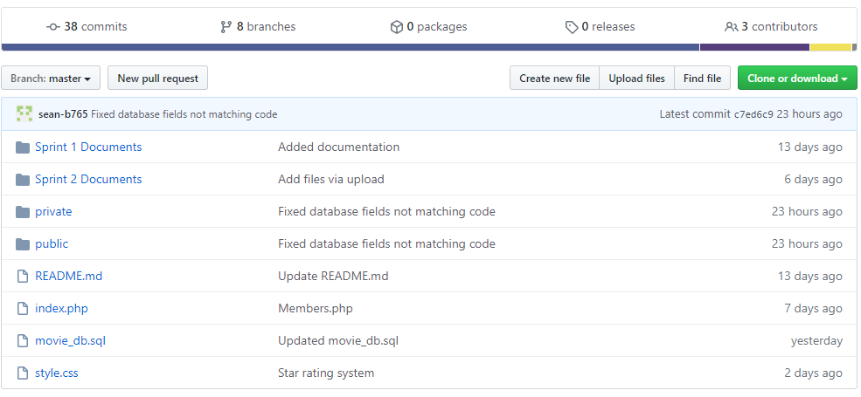

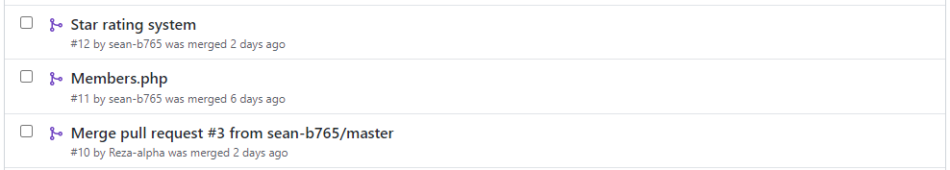

Some Pull Requests

## SPRINT 3 PROJECT MANAGEMENT PLAN

Updated by Sean *for Sprint 3*

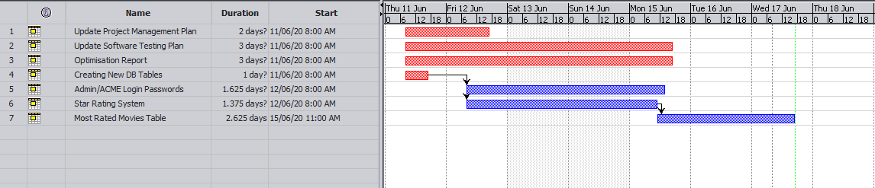

## SPRINT 3 TEST PLAN

Updated by Sean *for Sprint 3*

**Project: Movie Database**

**Client: Acme Entertainment Pty Ltd**

|  |  |  |  |
| --- | --- | --- | --- |
| **Version** | **Change Date** | **By** | **Description** |
| V0 | 28/5/2020 | *Gholamreza Aminy* | First Version |
| V1 | 7/06/2020 | *Sean Boaden* | Second Version – updated to meet requirements of Sprint Two |
| V2 | 10/06/2020 | Sean Boaden | Updated to meet requirements of Sprint Three |

Test plan 1

1. Introduction 3

Scope 3

In Scope 3

Out of Scope 3

Quality Objective 3

Roles and Responsibilities 3

2. Test Methodology 4

Overview 4

Test Levels 4

Bug Triage 5

Suspension Criteria and Resumption Requirements 6

Test Completeness 6

3. Test Deliverables 6

4. Resource & Environment Needs 7

Testing Tools 7

Test Environment 7

5. Terms/Acronyms 7

### Introduction

#### Scope

#### In Scope

The whole package including GUI, functional and non-functional requirements of the software are in the scope of this document and will be tested in different stages and sprints.

#### Out of Scope

None

#### Quality Objective

The ultimate objective of this plan is to ensure the application under test meets the functional and non-functional requirements as agreed on the contract. The Application Under Test will also be a quality and user friendly product with no defects.

#### Roles and Responsibilities

To ensure a clear understanding of the roles and responsibilities to achieve the above-mentioned quality objective the following roles and responsibilities are defined for this plan:

* Test Manager: has the overall responsibility of executing this plan. Test manager will schedule and implement the tests and set action plans to rectify the triaged bugs in cooperation with other team members
* QA Analyst: QA Analyst has the responsibility to monitor the proper implementation of this plan, perform regular audits and report to the Test Manager for corrections and Project Manager for further decisions.
* Configuration Manager
* Developers: are responsible to understand and analyze the assigned tasks and do the task on the assigned time ready for test. They will fix defined bugs during the tests reported by the Test Manager.
* Installation Team: They are responsible to ensure the software can be installed with minimum efforts and report any bugs to the Test Manager

### Test Methodology

#### Overview

Choosing the RAD software development requires a suitable test method like Agile in which all the functional and non-functional tests can be completed in each sprint. So the Agile method will be used for this testing plan as in Agile:

* software is developed in incremental, rapid cycles
* Interactions amongst customers, developers and client are emphasized
* focuses on responding to change rather than extensive planning
* every release of the project is tested thoroughly
* any bugs in the system are fixed before the next release

#### Test Levels

Test Levels define the Types of Testing to be executed on the Application Under Test (AUT).

The AUT will be tested in the below levels

* White Box Tests
  + Branch Coverage tests – can be performed on certain conditional operations. It is important that conditional bounds are tested on certain points, to ensure the application works well.
  + **Query Tests** – can be done with PHP or in a SQL test environment, depending on the type of query.

E.g. testing a query to get the most rated movies in the phpMyAdmin test environment:

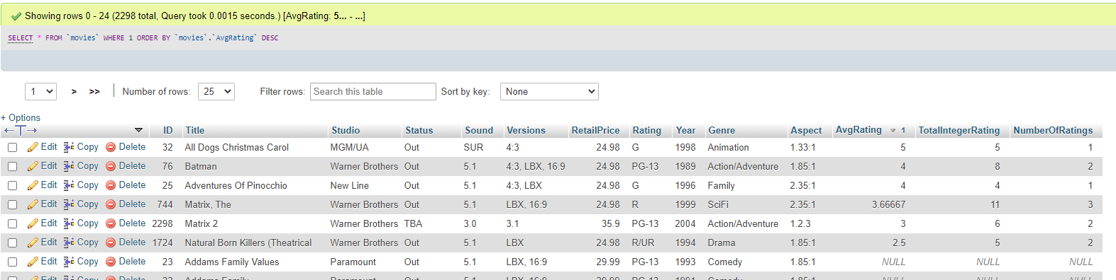

**Testing a query in PHP** is as simple as using *echo $sql;* when performing a query on a page. The query will be printed so you can see if there are any errors. Unfortunately it can be hard to control how this gets displayed.

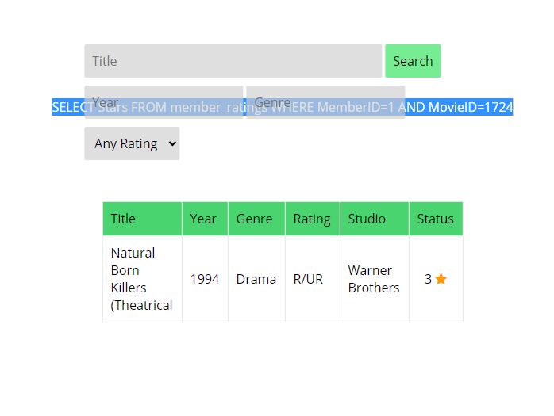

* Black Box Tests
  + **Functional tests** – where the new membership portal inputs will be tested. Sign up / sign in functions, administrative functions should be tested and documented.
  + **User interface** tests – will be used to test that the new members page follows the responsive design.

The following tests will be performed to ensure clients requirements:

* Functional and Regression Testing;
* GUI and Usability Testing;
* Accessibility Testing;
* Performance Testing;
* System / Integration Testing;
* User Acceptance Testing (UAT).

#### Bug Triage

To ensure fixing the bugs in a timely manner it is absolutely important to prioritize them so that the urgent ones, which are mainly functional reuquirements, get priority in scheduling the tasks to fix the bugs.

The triage would be based on the following requirements:

* Functional *(is now top priority as back-end coding plays a more important part for this sprint than user interface)*
* GUI and Usability
* Accessibility
* Performance

#### Suspension Criteria and Resumption Requirements

Due to size of the project, there is no suspension and resumption criteria.

#### Test Completeness

Test process will be considered complete if the following is met:

* 100% test coverage.
* All Manual & Automated Test cases executed
* All open bugs are fixed or will be fixed in next release

#### Test Deliverables

During different phases of the testing lifecycle the following deliverables should be delivered to ensure the testing process is completed and validated:

* Test Documentation Report
  + Test Plan
  + Test Cases
  + Bug Reports
  + Test Strategy
  + Test Metrics
* Customer Sign Off

### Resource & Environment Needs

#### Testing Tools

To run the testing plan the following tools are required and will be used:

* Test Management Tool
* Configuration management tool
* Static Analysis Tools [PHP Code Sniffer](https://github.com/squizlabs/PHP_CodeSniffer) with your desired coding standards

#### Test Environment

To test the application a test environment including hardware and software environement is equired in addition to the client specific ones.

Required hardware:

* PC or laptop
* Modem for internet connection
* Sufficient Disk Drive space

Required software:

1. Windows 10 / Mac OS / Linux
2. Email provider / individual preference
3. Git – to clone the source repository
4. XAMPP or similar web server software packages including MySQL and Apache
5. Text Editor such as Notepad++ or Visual Studio Code

### Terms/Acronyms

Make a mention of any terms or acronyms used in the project

| TERM/ACRONYM | DEFINITION |
| --- | --- |
| API | Application Program Interface |
| AUT | Application Under Test |

## OPTIMISATION REPORT

By Gholamreza

### Definition

In general, trying to achieve the best design and performance related to a set of prioritized criteria or contraints which is achievable by maxamizing the productivity, strength, reliability, longevity, efficiency, and utilization factors. This process of decision making is known as optimization process.

Code Optimization in Compiler Design. The code optimization in the synthesis phase is a program transformation technique, which tries to improve the intermediate code by making it consume fewer resources (i.e. CPU, Memory) so that faster-running machine code will result. (geeksforgeeks, 2020)

### Objectives

The main objectives of the code optimization can be:

* Increases the compilation’s speed by reduce the space usage.
* An optimized code often promotes re-usability.

### Types of Code Optimization

In general there are two types of optimization proces:

* Machine Independent Optimization

This code optimization phase attempts to improve the intermediate code to get a better target code as the output. The part of the intermediate code which is transformed here does not involve any CPU registers or absolute memory locations.

* Machine Dependent Optimization

Is normally done after the target code has been generated and when the code is transformed according to the target machine architecture. It involves CPU registers and may have absolute memory references rather than relative references. Machine-dependent optimizers put efforts to take maximum advantage of the memory hierarchy.

### Code Optimization Methods

Code Optimization is done in the following different ways :

* Compile Time Evaluation
* Variable Propagation
* Dead code elimination : Variable propagation often leads to making assignment statement into dead code
* Code Motion :  
  • Reduce the evaluation frequency of expression.  
  • Bring loop invariant statements out of the loop.
* Induction Variable and Strength Reduction :  
  • An induction variable is used in loop for the following kind of assignment i = i + constant.  
  • Strength reduction means replacing the high strength operator by the low strength.

### Where to apply

The best place for applying the optimization could be:

* Sourceprogram  
  Optimizing the source program involves making changes to the algorithm or changing the loop structures where the user is the actor.
* Intermediate Code  
  Optimizing the intermediate code involves changing the address calculations and transforming the procedure calls involved. Here compiler is the actor.
* Target Code  
  Optimizing the target code is done by the compiler. Usage of registers, select and move instructions is part of optimization involved in the target code.

### Phases of Optimization

There are generally two phases of optimization:

* Global Optimization:  
  Transformations are applied to large program segments that includes functions, procedures and loops.
* Local Optimization:  
  Transformations are applied to small blocks of statements. The local optimization is done prior to global optimization.

## TEST DOCUMENTATION

Fixing a error with analytics, LastUpdate field only changes when insertting new record, not when updating a search result.

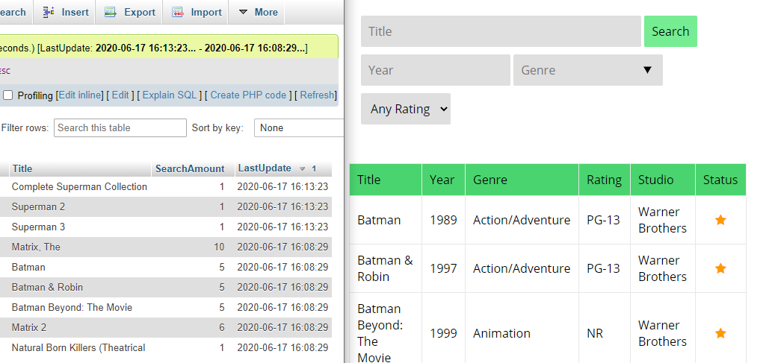

To fix this, I updated a row in phpMyAdmin to see what SQL function was used to select the current time.

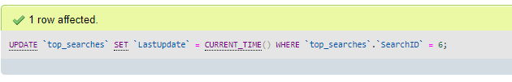

The UPDATE query now looks like this:

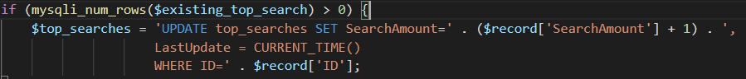

Errors are displayed if a member does not belong to a group, in the group_members table.

When a new user signs up, they are now automatically placed in the Users group.

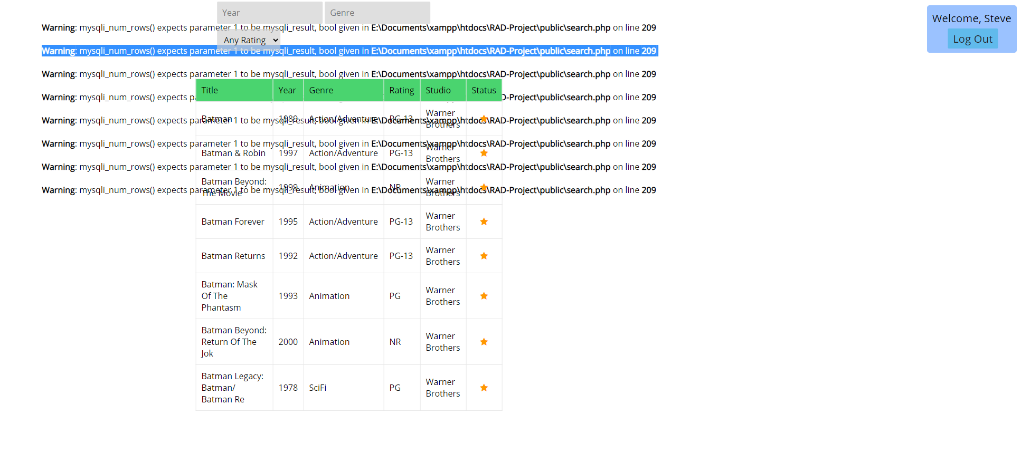

**Admin login**

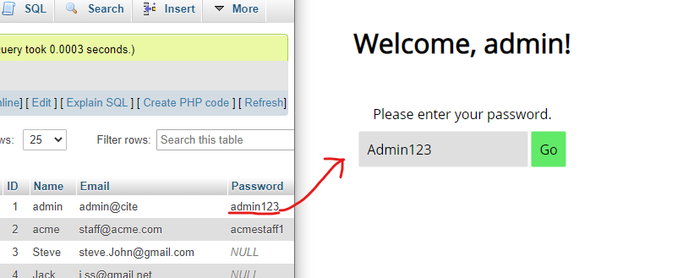

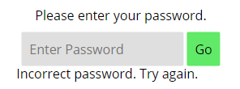The capitalised password did not work.

**Changing / Setting password**

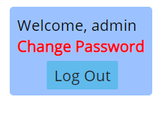Pressing the ‘Change Password’ notification will redirect to members.php,

where Admins/ACME staff are prompted to set a password.

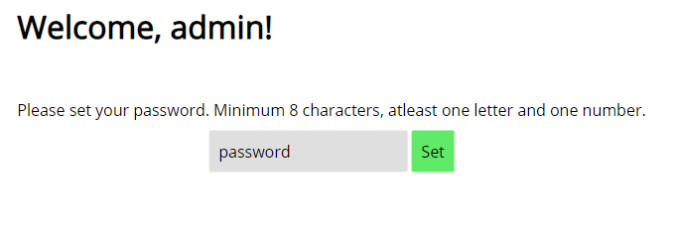

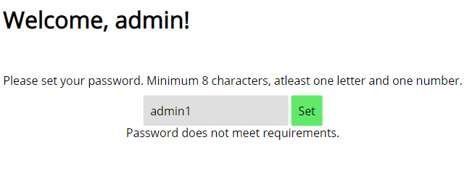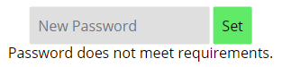

The password MUST be atleast 8 characters, and contain a letter and number.

## Analytics

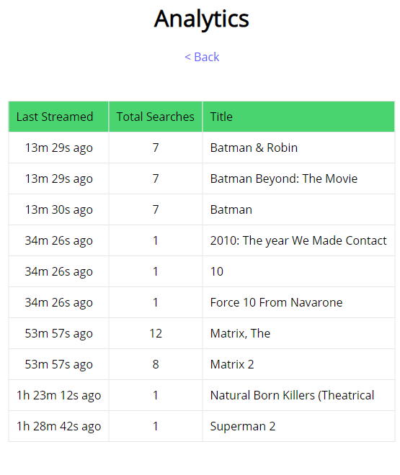 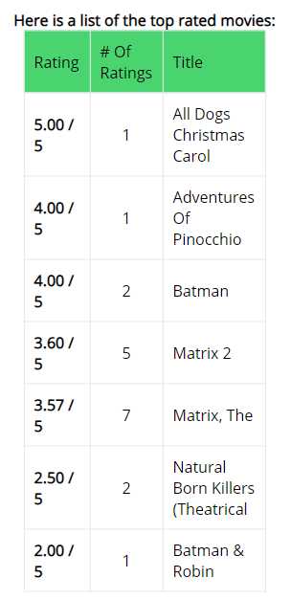

Top 10 movies can be queried from movies table, taking the AvgRating field in descending order. Each time a user rates a movie, their rating is saved to their member ID, and the movies table is also updated.

TotalIntegerRating, NumberOfRatings fields are used to calculate the AvgRating field.

Currently streaming movies can be the most popular, or most searched for movies at the current time.

The current top_searches table already stores the movies and the amount of times it was searched for. The SearchAmount field is incremented when the movie appears in somebodies top 3 search results.

To display historical streaming data, it will have to contain a LastUpdate field, to compare with other recent searches.

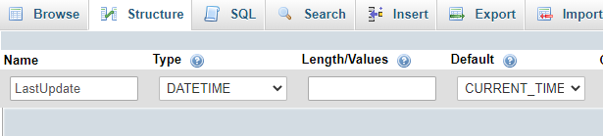

Using SQL TIMEDIFF(time1, time2) as a PHP query function, we could find the time since the last search.

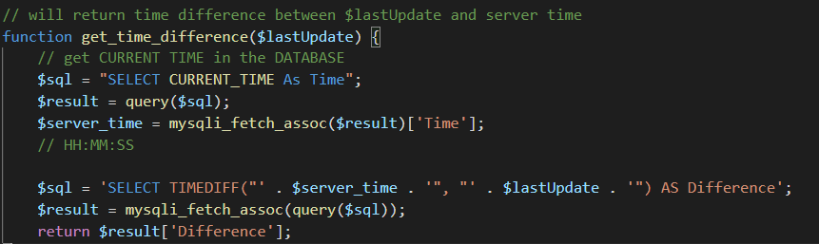

## Password Authentication

Passwords are required to be set for ACME and Admin accounts. This is done by testing if the Passwords field is null or empty for those users which belong to ACME and Admin group.

If their password is not set, they are told to change password immediately:

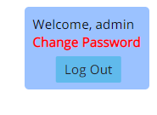

Clicking Change Password redirects to members.php, which can only be accessed when Admins or ACME users have a password set.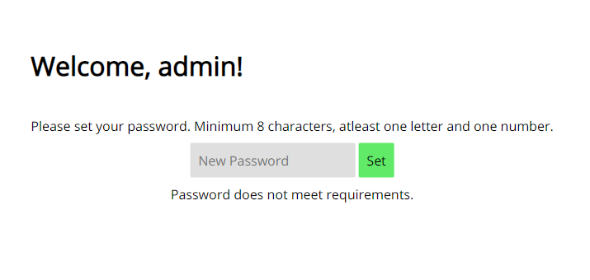

The password is validated against a Regular Expression using the PHP function preg_match()

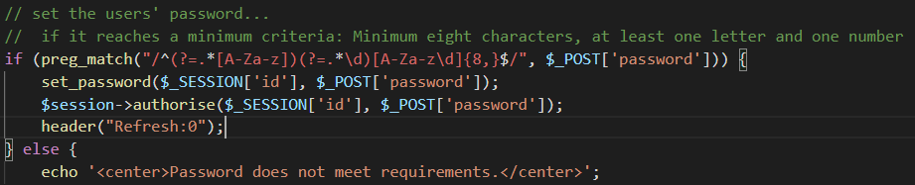

This will set the $_SESSION[password], and will also set the password in the database.

When logging in, it is a similar process, except the set_password() function and preg_match(RegEx, str) functions are not used.

# References

CITE business rules for software development: <http://www.citems.com.au/?page_id=74>

Functional vs. Nonfunctional Req. - <https://reqtest.com/requirements-blog/functional-vs-non-functional-requirements/>

Software Verification - <https://blackboard.southmetrotafe.wa.edu.au/bbcswebdav/pid-1719638-dt-content-rid-15646676_1/courses/16_C_EIO_BUSAPPCLU_1/verification.pdf>